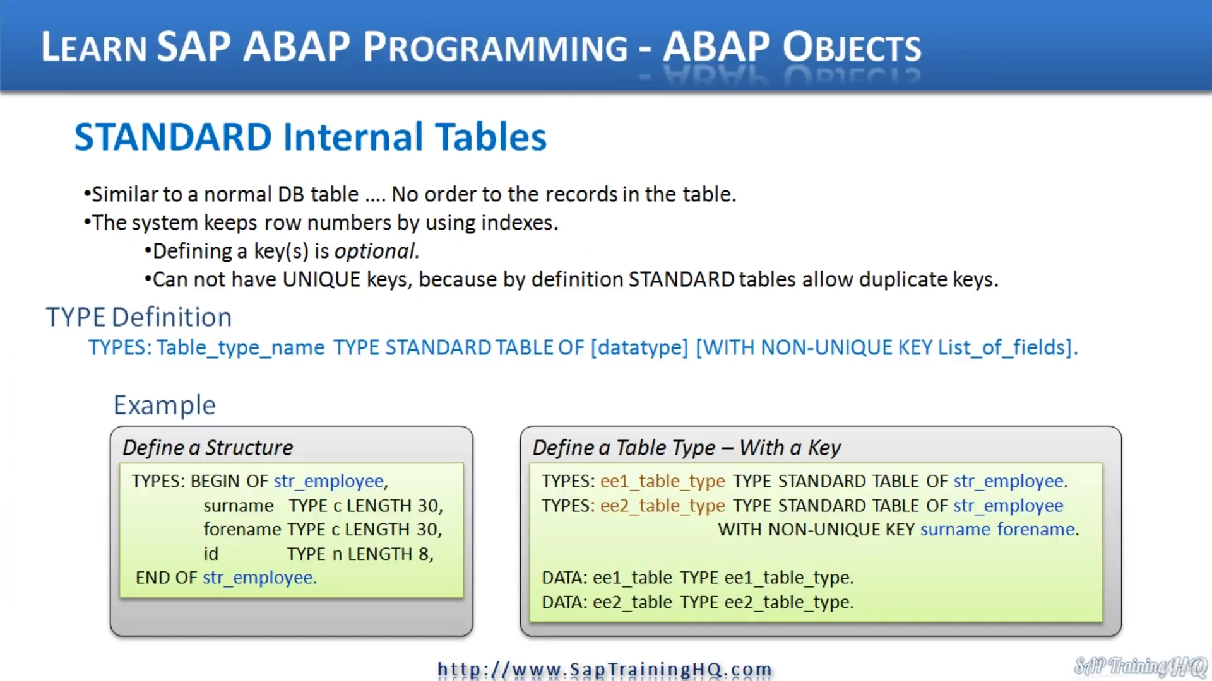

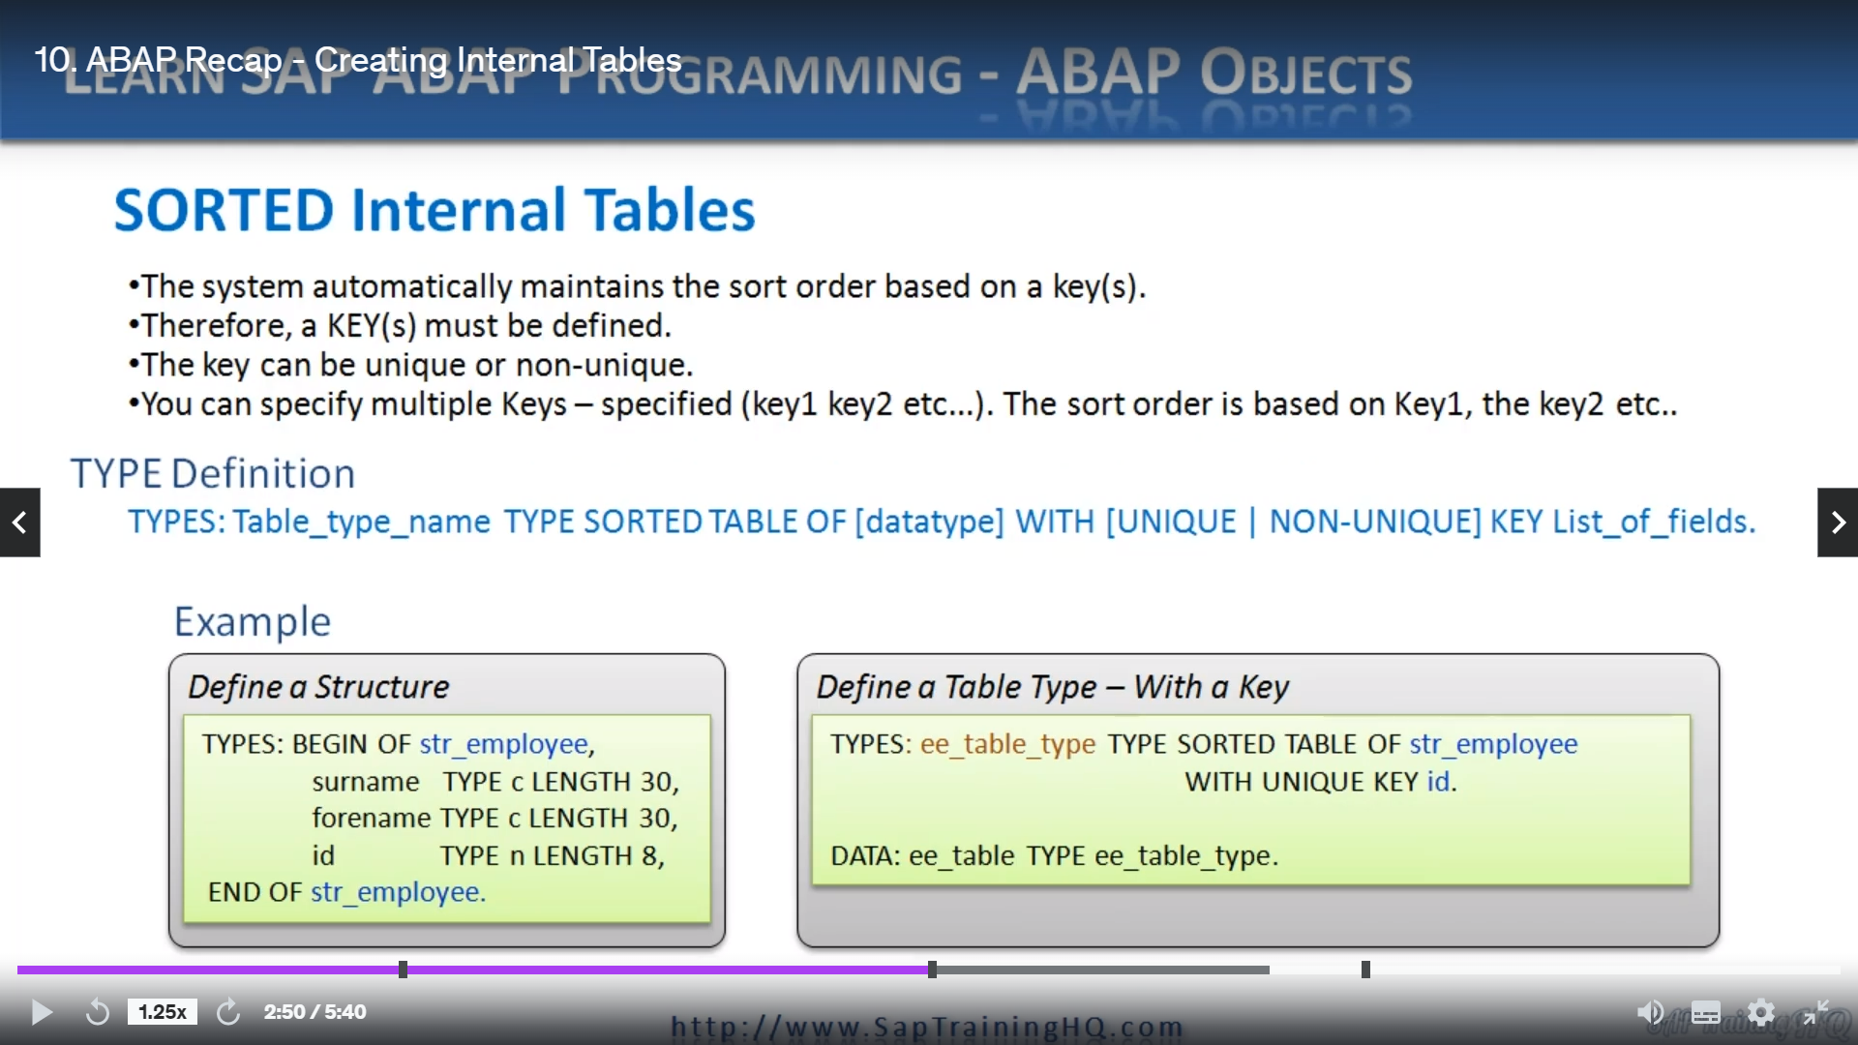

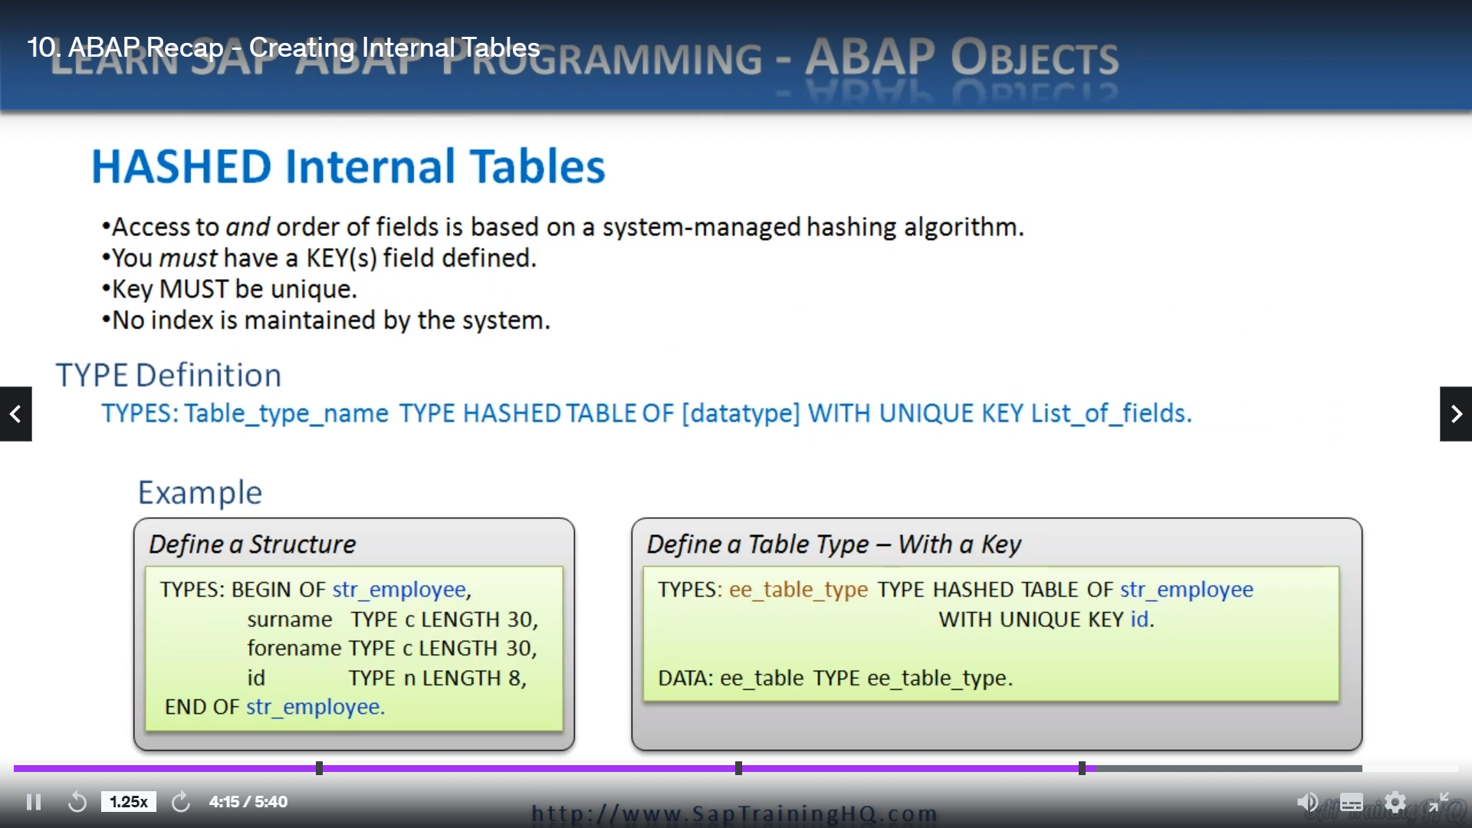

Let's have a look at internal tables in more detail and we'll start with standard internal tables.

Now, this type of internal table is very similar to a database table in that when data is stored in

the database table, it's stored in a sequential fashion.

As the records are created, there is no order to the records, but internally to the system.

It does use phone numbers to keep track of the records in the table.

Now you have the option of defining keys to work with your on the table, and this is there to help

improve efficiency when you're reading data from the table.

But importantly, these keys have to be non-unique keys because by definition, standard table's always

allow duplicate keys and that's where they differ from normal database tables because with a normal

database table, you can define unique keys.

Now, let's go straight on and see how we define the type that we base our internal tables on, so down

the bottom part of the slide here, we can see we have these type statements followed by a time name,

then we specify type standard table of and we specify the structure.

And then we have the optional parameters of saying with non-unique key and then we list the fields out

that make up the key.

So in the example here, here we have the structure.

And then on the right hand side, we have two sets of examples, we have types and we're specifying

a type name so easy, one on the table and the skull type and we say type stuff, the table of and then

we specify the structure.

We're basing this table on the second example, exactly the same.

But finally, we're adding the Non-unique Keys edition, followed by the individual fields we want to

order our records by.

And when we actually come to instantiate actually create the internal table, we use the normal dates,

a statement and we say Data Kawan is a table name.

And it's based on the type.

That we have just defined Iwon and skull table and skull type and the second example, exactly the same

process for creating an internal table based on a standard table type with non-unique keys.

Pretty simple stuff.

Next, we have sorted internal tables.

These are very similar to standard internal tables, but the main difference here is we must specify

a key and we have the option of saying whether the keys in this instance are unique or non-unique.

And when we define the keys, we have the option of defining multiple keys if we like to help speed

up data access.

And on any of the keys that we specify, the court order is based on the sequence in which we create

the keys.

So let's have a look at the time definition we have typed.

Then a table taken which specify type sorted table of.

With the structure and then we aren't with either unique or non-unique key then list of field names.

Let's go straight down to the example is our structure again for the type statement we give the give

the type A name and we say type salty type of our structure with unique ID, which is this field here.

When we want to create the internal table, we use the data statements again, give me a table name

and say our table type is based on the time we have just created each on this goal table type.

Next, we have hashed internal tables now hushed internal tables do differ to standard unsorted in a

number of ways.

And the main feature is a hushed internal table.

We must specify a unique key.

We are not allowed non-unique keys.

And when we specify unique, realized the system doesn't create an index that it would then use to read

the data, what it does is it uses a special hashing algorithm to give us superfast access to the records

we need to read based on the keys we defined.

So straight down to the time definition we have typed table time name, then we specify type hash table

of then the rest is pretty similar to the previous internal tables.

We specify a type of table, then we say with unique key and we list the fields sound.

There's a structure on the left and on the right hand side you can see the time definition in the example

where we're specifying the type hash table of using the structure.

With unique I.D. again.

Then when we want to create the table, we say data table name based on the type the time we have already

defined.

So pretty simple stuff.

And you should be familiar with this, but it's worth going over.